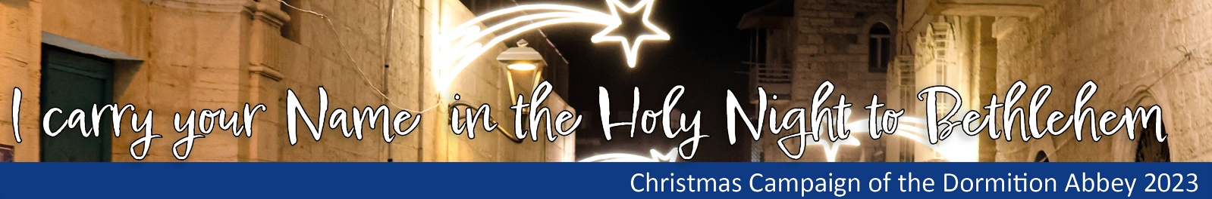

Monks and young people from the dormition abbey in Jerusalem bring many names to the Grotto of Bethlehem on Christmas Eve and pray for these people. Please send us the list of people to whom you have brought the light and we will send them all to Jerusalem. Tell the recipients of the light that they will be prayed for in Bethlehem on Christmas Eve. Send the list by 20.12.23 to meinolfwacker@gmx.de

Nr. | First Name and Family Name

